Page | 01

**MSc (CS) Part - I**

**Subject:** Applied Signal and Image Processing

**Practical No: 01**

**Aim:** Write program to demonstrate the following aspects of signal processing on

suitable data.

**A:** Upsampling and Downsampling on Image/speech signal.

**Upsampling:**

Upsampling is the increasing of the spatial resolution while keeping the 2D representation of an image. It is typically used for zooming in on a small region of an image, and for eliminating the pixilation effect that arises when a low-resolution image is displayed on a relatively large frame.

**Program Code:**

from PIL import Image

import pylab

import numpy

img=Image.open(r'C:\Users\ITLAB4-PC\Pictures\nature.jpg')

pylab.imshow(img)

pylab.show()

upScaleImg=img.resize((img.width*2,img.height*2),Image.Resampling.NEAREST)

pylab.figure(figsize=(10,10))

pylab.imshow(upScaleImg)

pylab.show()

**Output:**

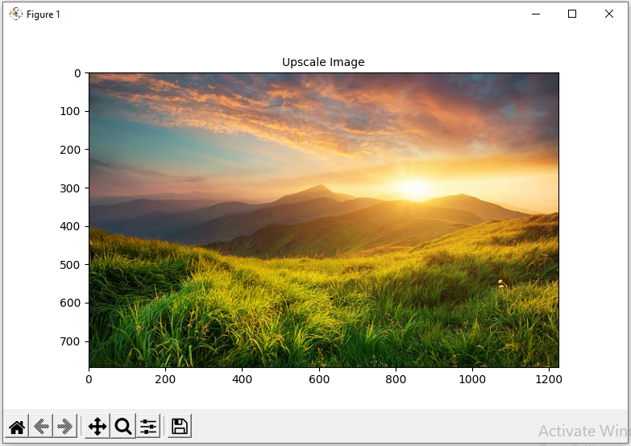

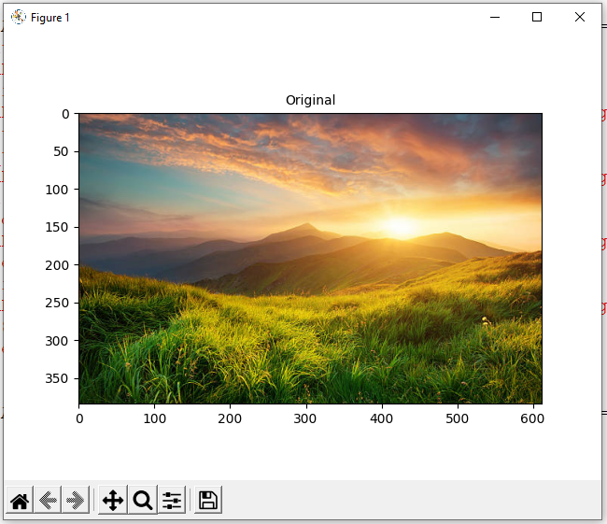

Page | 02

**Downsampling:**

Downsampling is the reduction in spatial resolution while keeping the same two-dimensional (2D) representation. It is typically used to reduce the storage and/or transmission requirements of images. Upsampling is the increasing of the spatial resolution while keeping the 2D representation of an image.

**Program Code:**

from PIL import Image

import pylab

import numpy

img=Image.open(r'C:\Users\ITLAB4-PC\Pictures\nature.jpg')

pylab.imshow(img)

pylab.show()

downScaleImg=img.resize((img.width//2,img.height//2),Image.Resampling.NEAREST)

pylab.figure(figsize=(10,10))

pylab.imshow(downScaleImg)

pylab.show()

**Output:**

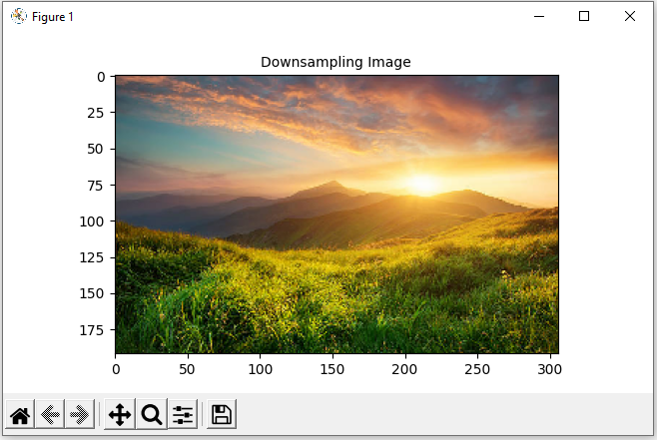



Original Image

Page | 03

**B:** Fast Fourier Transform to compute DFT.

Page 3

The Fast Fourier Transform (FFT) is commonly used to transform an image between the spatial and frequency domain. Unlike other domains such as Hough and Radon, the FFT method preserves all original data.

**Program Code:**

from PIL import Image

import numpy as np

import scipy.fftpack as fp

import pylab

im=np.array(Image.open(r'C:\Users\ITLAB4-PC\Desktop\Ravi\testing\car.png').convert('L'))

freq=fp.fft2(im)

im2=fp.ifft(freq).real

pylab.figure(figsize=(20,10))

pylab.subplot(121),pylab.imshow(im,cmap='gray'),pylab.axis('off')

pylab.title('Original image',size=20)

pylab.subplot(122),pylab.imshow(im2,cmap='gray'),pylab.axis('off')

pylab.subplot(122),pylab.imshow(im2,cmap='gray'),pylab.axis('off')

pylab.title('recontruction image',size=20)

pylab.show()

Plotting Spectrum Frequency

freq2=fp.fftshift(freq)

pylab.figure(figsize=(10,10))

pylab.imshow((20*np.log10(0.1+freq2)).astype(int))

pylab.show()

**Output:**

